FOUR BROTHERS. ALL TURNED VAMPIRES BY THE SAME EVIL SIRE. THEY ARE THE LORDS OF BLACKNALL, IN THIS CENTURY. TRINITY IS THE SECOND OLDEST AND WHILE STARTING TO INVESTIGATE THE MURDER OF WOMEN ON LONDON'S EAST SIDE, HE SUDDENLY FEELS A WOMAN IN DANGER. WHY HER? AND WHY DOES THIS ONE WOMAN'S BLOOD SET HIS THIRST ON FIRE. CAN TRINITY SAVE LADY BETH FROM THE MONSTER THAT HUNTS HER? CAN HE EVEN PROTECT HER FROM HIS OWN WICKED URGES, WANTING TO DEVOUR HER?
VAMPIRE LORDS OF BLACKNALL :

VAMPIRE LORDS OF BLACKNALL:
Trinity
ONLY A CREATURE OF THE NIGHT CAN SAVE HER.

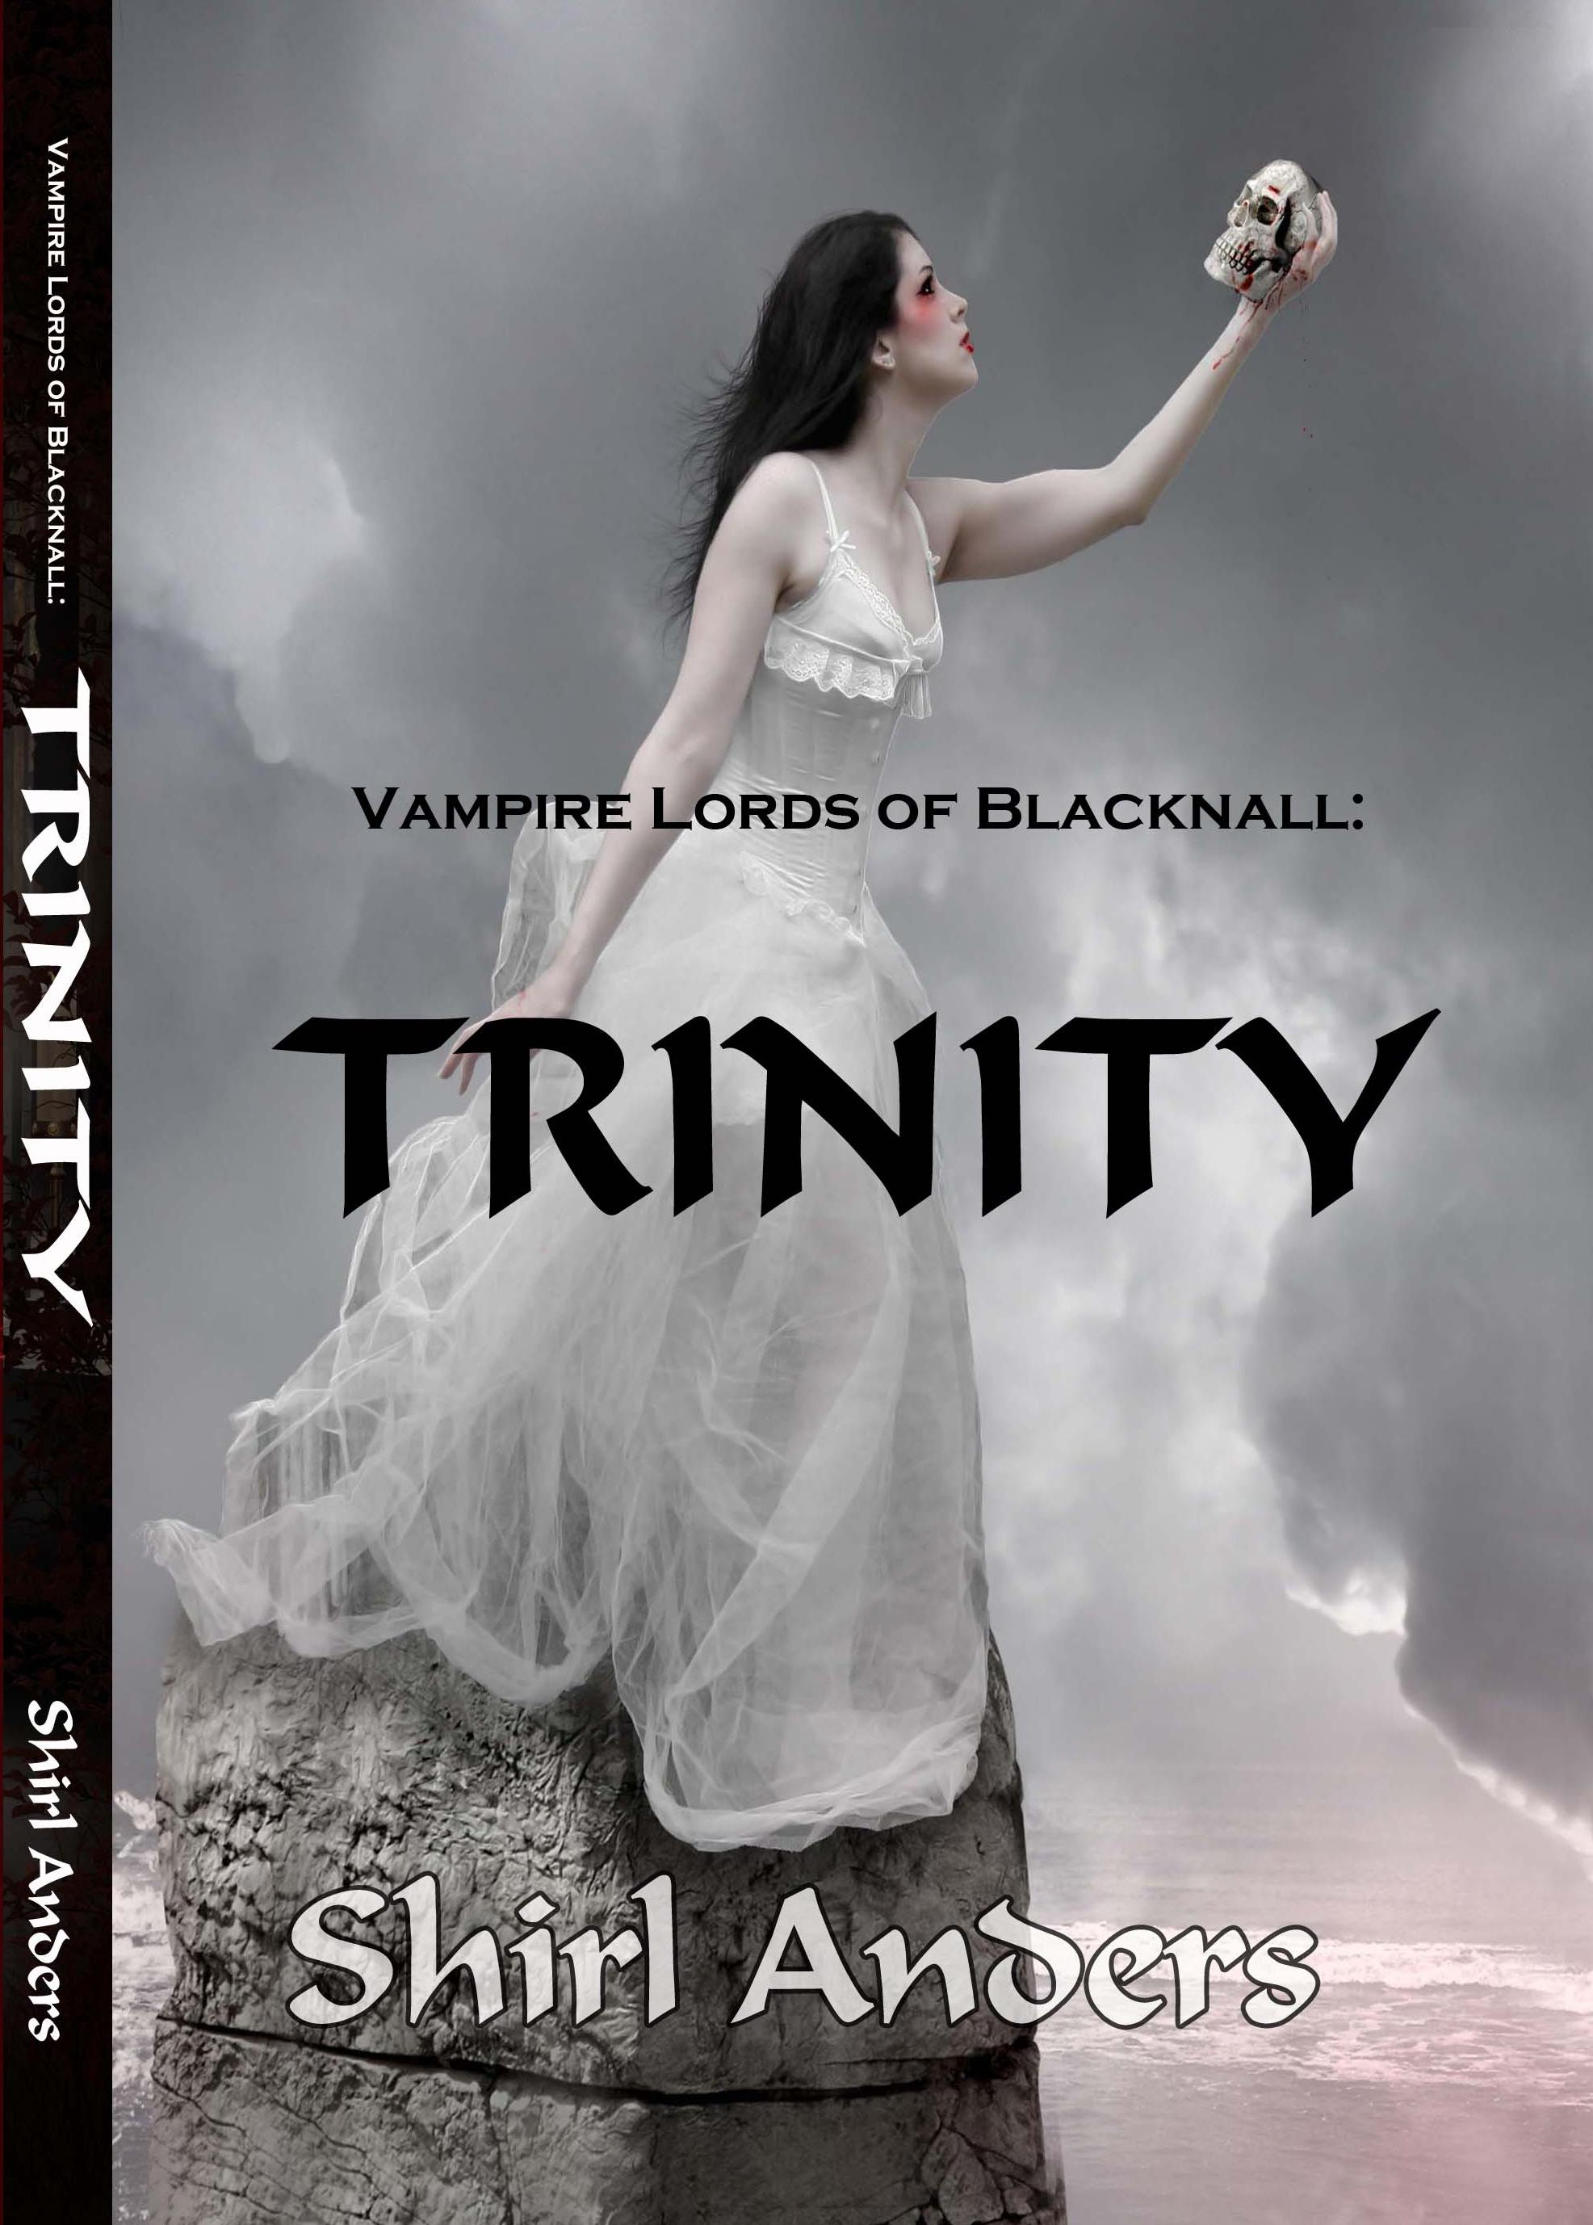
m
0
0
0
11
co C) z r
LADY BETH WINSLOW NEVER STAYS HOME IN THE EVENINGS. SHE FEARS HER DESPICABLE STEPBROTHER. THEN A MONSTER STALKS HER IN THE DARK WOODS AND SHE CANNOT TELL BEAST FROM SAVIOR. GOTHIC UNDERTONES FILL THIS VAMPIRE REGENCY ROMANCE NOVEL.

IF YOU'VE READ SHIRL ANDERS BEFORE YOU WILL BE SURPRISED. THIS IS A NOVEL LENGTH STORY WITH ALL OF SHIRL ANDERS STYLE, BUT MUCH MORE SATISFYING AND LENGTHY ROMANCE.
SHIRLANDERS


